- Please overwrite the blue parts with your manuscript in black.
- Please delete all the red parts before sending your manuscript.
- Color figures are acceptable, however printed version will be black and white (online version will be color).
- Header, Footer and margin of pages must not be changed.
- Only “Times New Roman” and “Symbol” should be used as font (Local font is not acceptable).
- This paper should not exceed 6 pages.
<Title, font size 14, Bold> TITLE WITH AT MOST THREE LINES IN UPPERCASE LETTERS: MAY CONTAIN Σ OR CHEMICAL FORMULA AND IONS LIKE O₂ H₂O NO₃⁻ -N
<Subtitle, if necessary, font size 12, Bold> ― Fuzzy, Neural, Chaotic and Genetic Systems ―
<Author(s), font size 12> Taro Sojo^{*1}, Jiro Kumamoto ²
<Affiliation, font size 10> ¹Sojo University,
<Address, font size 10> 4-22-1 Ikeda Kumamoto City, Japan
² Fuzzy Logic System Institute
1-5-204 Hibikino, Wakamatsu-ku, Kitakyushu 808-0196, Japan
*Corresponding author <<E-mail address of corresponding author, font size 10>T-Sojo@cis.sojo-u.ac.jp>

Abstract <Abstract, font size 11 in italic type> This is the word template for full paper submission for Hybrid 2016. Please give a short abstract here with in 500 words. The paper should not exceed 6 pages in total. Only you can use the font of Times New Roman and Symbol, do not use double-byte character or multi-byte character.

Keywords: <Keywords, less than 10, font size 10> agriculture, biotechnology, microbe, food science, IT technology, agricultural chemistry, crops, farm products, a pest control, properties of water, Plasma sterilization

Potential Applications to: <Potential applications related to this hybrid conference, font size 10> Traditional Agriculture (TA), Information Communication Technology (ICT), Food Science (FS), Plasma Electronics (PE)

- Introduction
<body text, font size 11> Please do not change any formatting. The text can be structured in several numbered sections. Acknowledgment and references section should not be numbered.

- Header
The header contains the title, authors, author affiliations and e-mail address of the first or the corresponding author. Do not change the page margins or formats. Use Times New Roman with 14 pt font size for the title. The title should be in bold uppercase letters in up to three lines. It may contain special characters as given in the example above. Authors are written in the same font, but 12 pt and regular. Affiliations are in the same font with 10 pt. Use superscript numbers for different affiliations as shown above. E-mail addresses are 10 pt. Do not write “E-mail” before the e-mail address.

- Main text with figures, tables and equations
The body text is in Times New Roman 11 pt. Section headers are in 12pt in bold. The text can contain citations [1-4]. Examples of citation formatting are given below. The first line of every paragraph, except the lines next to the section headers, should be indented 1/4 inch.
Equations should be numbered and referred as equation (1).

(1)

If you insert an image, numerate them and use a caption as shown in the Figure 1 and referred in the text as “Figure 1”etc. Captions and figures should be centered. Caption font is the same as for the body text but in bold with 10 pt.
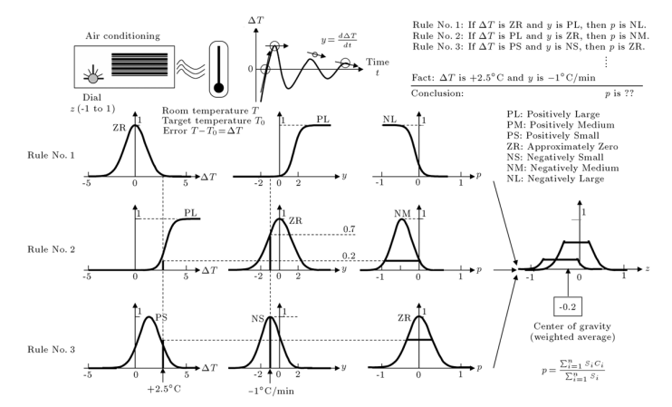
<Figure title, should be sequentially numbered, should be below the corresponding figure, font size 10, Bold>Figure 1. Example Image of figure <Figure caption if neccesary, font size 10>

Tables should be handled like figures (but left-aligned with numbered caption) but with caption above the table and referred in the text as “Table 1”etc.

<Table title, should be sequentially numbered, should be above the corresponding table, font size 10, Bold>Table 1. Summary of font size
Part | font size
Title | 14 pt
Subtitle | 12 pt
Author | 12 pt
Affiliation, address and E-mail address | 10 pt
Heading and sub-heading | 12 pt
Body text | 11 pt
Figure and table title and caption | 10 pt

You may use figures, tables and as many references as you need, but the paper should not exceed 6 pages in total. Please do not add page-numbers. Create a PDF file from the Word document and submit it via the conference web site.
http://www.cis.sojo-u.ac.jp/~hybrid2016/index-e.html

- Conclusions
In this paper, ………………………

Acknowledgment
Here you can place any acknowledgements related to your contribution.

References
[1] A. Author, B. Author, and C. Authors, Journal, volume (issue): pages (YEAR)
[2] A. Author, Title of Book, Edition. Publisher, City, (YEAR)
[3] A. Author and B. Author. In E. Editor and F. Editor, editors, Title of Book, pages. Publisher, (YEAR)
[4] A. Author and B. Authors, In <Name of Conference> Proceedings, Vol. X, page. (YEAR)

